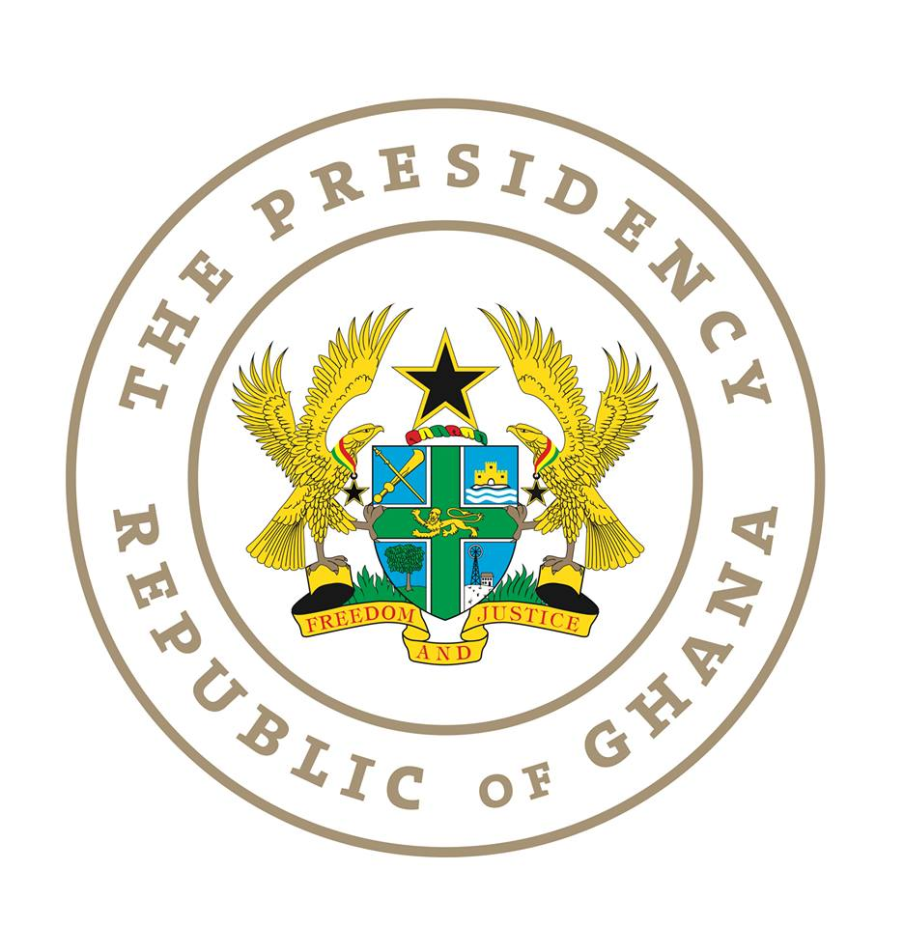

SPEECH DELIVERED BY
H.E. DR. MAHAMUDU BAWUMIA
VICE PRESIDENT OF THE REPUBLIC OF GHANA

AT THE VALUE FOR MONEY CONFERENCE IN THE CONSTRUCTION OF ROADS, SCHOOLS AND HOSPITALS

Honourable Ministers Present
Chief Executive Officers
Development Partners
Members of Academia
Civil Society Organizations
Captains of Industry
Friends of the Media
Ladies and Gentlemen

- It is indeed a great honor to be here with all of you today and to participate in this important discussion on “Value for Money in the Construction of Roads, Schools and Hospitals

- I wish to start by expressing profound gratitude on behalf of His Excellency, the President Nana Addo Dankwa Akufo Addo and the entire Government, to all the participants who have travelled from different places to be here with us today.

- I do hope you have already experienced, and will in the coming days experience even more of the proverbial Ghanaian hospitality throughout your stay here.

- We have gathered here to establish how our country can get value for billions of Cedis invested in the construction of Roads, Schools and Hospitals.

- Ladies and Gentlemen, Infrastructure is amongst the most important contributors to the economy of every country. It plays a significant role in generating revenue for economic development and provide support for a growing population.

- The Wold Bank estimates that on average, Ghana invests ~$1.2bn per year in Infrastructure projects. The Africa Infrastructure Diagnostic Report in 2010 (AICD) also identified that $1.1bn is lost each year, in Ghana, on Infrastructure projects due to project delivery inefficiencies and for Ghana to meet its infrastructure deficit, $1.5bn is required, each year for the next 10 years.

- Over 90% of corruption is related to procurement, It is therefore very important that we pay attention to the procurement processes.

- Current project costs are believed to be in excess of those accepted in the sub-region and globally. For instance, a comparative analysis reveals that better-quality hospitals are currently built at a more cost-effective rate in India than in Ghana.

- At a recent meeting of the EMT, it emerged that Ghana constructs district 60-80 bed district hospitals for $25 million! I said “Ebei!”. You will here today that the African development Bank constructed a 150 bed hospital in Accra for some GHC5.76 million or $1.3 million without equipment. Even if we have to equip this hospital for some $1 million, the total cost cannot get to more than $3 million. So how come we are building district hospitals for $25 million, a figure which even excludes the tax exemptions granted on equipment imported for the hospitals? So for one hospital that Ghana is currently constructing, we could have built and equipped 6 hospitals!

- According to some estimates, if Dangote can build a 1000 bed capacity for nearly under $20 million, it begs the question why Ghana builds an even smaller capacity (about 400-bed facility) for nearly $300 million. Something is not right here.

- It is therefore imperative that at the same time as seeking suitable investment opportunities to meet the infrastructure gap that the Government takes steps to ensure cost efficient program design and delivery to reduce financial wastage and protect the public purse.

- Ladies and Gentlemen, it is this respect that this Government under the leadership of His Excellency the President Nana Addo Dankwa Akufo- Addo has committed to seeking the investment required for the construction of Roads, Schools and Hospitals, and at the same time, maximising the efficiency of existing expenditure on these infrastructures to ensure Value for Money.

Value for Money
- Value for Money is an overused phrase in public procurement. Many procurement decisions we are told, have been made with the goal of attaining fit for purpose, efficiency and effectiveness. Yet, in the end, our infrastructure projects are typically characterised by huge cost overruns and undue delays, which eventually fail to deliver on its objectives to the ultimate beneficiaries.

- Indeed, several examples can be cited of major procurement contracts “gone bad”. Ghanaians remember all too well the infamous bus branding procurement which cost the taxpayer over GH₵3.6 million (or nearly $900,000 then). On an average, it is estimated that about 10-15% or more of contract values are lost to corruption and cost overruns.

- Ladies and Gentlemen, Value for Money in public procurement therefore refers to a judicious, economic and efficient use of state resources at a reasonable cost. It is not about achieving the lowest initial price but rather, the optimum combination of whole life costs and quality and arriving at best contract terms for Ghana.

- According to experts, Value for Money in the public sector shows up in the contributions that procurement decisions can make in advancing government policies and priorities while achieving the best return and performance for the money being spent.

- At the heart of the concept of Value for Money, are three critical elements namely economy, efficiency and effectiveness.

- The Public Procurement Act, 2003 (Act, 663) as amended provides the legal framework and the basis to ensure the attainment of the seven (7) “Rights” in public procurement, namely:

  - The Right Quality of goods,
  - Delivered at the Right Time,
  - To the Right Place,
  - In the Right Quantity,
  - From the Right source,
  - At the Right Price

- As some of you may know, the Public Procurement Act is the main law that guides procurement by the public sector of Ghana. The purpose of the Act is to ensure responsible public procurement and value for money for government. As a result, several structures were created under the Act to ensure that public procurement is done transparently and objectively, with a view to ensuring that public funds were not wasted.

- Primary among these were the Entity Tender Committees which all public institutions were required to set up to monitor and supervise their procurement processes to ensure compliance with the law and the Value for Money audits of public contracts. All of these are supervised by the Ministry of Finance and Public Procurement Agency.

- The Value for Money assessment service that the Government of Ghana requires involves more than a procurement value for money audit. It involves a detailed contract risk analysis and assessment covering every aspect of the contract, including the physical format of the contract.

- The VFM service provider must therefore, in addition to doing an effective procurement assessment, be able to do a thorough contract risk assessment to reveal all latent flaws in the contract in order to guide the Government of Ghana to make informed decisions in renegotiating less than favourable contract terms.

- To achieve the objectives of a good procurement system in the construction of Roads, Schools and Hospitals, the following factors are of utmost importance: Professionalism; Transparency; Value for money; Competitiveness and Accountability. Other factors include Fairness; Efficiency and an ethical approach to the conduct of procurement functions.

- Ladies and Gentlemen, whether it is transportation, power, water, or public buildings including schools and health facilities, how can we ensure value for money in building the infrastructure we so badly need for the structural transformation of the economy?

- Infrastructure is an integral aspect of society because if affects our productivity, how we access goods and services and the overall quality of life. Good infrastructure can even reduce poverty and income inequalities because they provide access to markets. We look forward to the conference outcome on how to build a prosperous economy at the right cost, efficient and long lasting. What is the level of professionalism needed to make this possible?

- Is it possible to have standardized unit costs of building basic schools, clinics, feeder roads, asphalt and concrete roads? Let us acknowledge that it has not been well in the past. We are here to problem solve and we need solutions

Ladies and Gentlemen, we should come out of this conference with an extensive report wherein applicable solutions to the high cost of constructing roads, schools and hospitals in Ghana will be identified. Following this conference, we would like to come out with standard designs for schools, hospitals, and roads with their accompanying bills of quantities. We should therefore be able to set maximum costs for constructing a district hospital or a six unit class room block to guide the procurement process.
- Ladies and gentlemen, once again, I welcome you all and wish you fruitful discussions. To our friends from outside the country, I say Akwaaba in the true Ghanaian sense of the expression, and I look forward to your report.

- Thank you. God bless our homeland Ghana. God bless us all.

